6.1. Implementation Details
Common experimental protocol. All three problems are evaluated on the Jetson Nano 4GB (JetPack 4.6, CUDA 10.2). Table 6.1 summarizes the key parameters used across Re-Identification, Identity Association, and Boundary Feature Fusion, reflecting the architecture actually deployed and measured rather than earlier design iterations.
Problem | Parameter | Value
Re-ID | Model | OSNet x0.25, distilled from OSNet x1.0 (Knowledge Distillation)
Re-ID | Training loss | 1.0×CE + 1.0×Triplet (margin 0.3) + 0.5×KD (MSE on L2-normalized embeddings)
Re-ID | Optimizer / schedule | Adam, lr 3.5e-4, wd 5e-4; early-stopped at epoch 56 (best: epoch 46)
Re-ID | Gallery match threshold | 0.6 (cosine similarity)
Identity Assoc. | Floor calibration | One-time 4-point homography, 0.7 m reference square
Identity Assoc. | Matching | Hungarian algorithm; distance threshold 0.5 m
Boundary Fusion | Fusion weight | Gaussian, σ = 2.0 (selected via sweep, Section 6.4)
Boundary Fusion | Height levels | 8 levels, 0–2 m (H_by_height homography family)
Boundary Fusion | Cross-camera pairing threshold | 1.5 m (looser than Identity Association's 0.5 m, since the two cameras project onto separate floor planes)
Boundary Fusion | Fall decision rule | transition to ‘lie’ ≤ 2 s OR sustained lying ≥ 1.5 s; ~1.2 s detection grace-hold to bridge missed frames
Table 6.1 — Key implementation parameters, by problem.

6.2. Baseline Reimplementation and Adaptation

6.2.1. Baseline for P1 — Shared-Backbone Re-ID Head
Baseline. The internal baseline for Re-Identification is the team's own original design: rather than a separate model, a Re-ID head (Linear + BNNeck + classifier) is attached directly to the Pose Head's existing YOLOv8n-cls backbone, trained on MSMT17. The motivation was resource efficiency — avoiding a second model on the Jetson Nano 4GB. Four independent training configurations were tried to rule out a configuration error rather than a fundamental limitation, summarized in Table 6.2.
# | Configuration | Rank-1 | mAP
1 | Frozen backbone, CE + Triplet, 60 epochs | 4.88% | 1.11%
2 | Unfrozen backbone, 20 epochs | 3.72% | 0.87%
3 | Unfrozen backbone, 60 epochs (original design) | 3.48% | 0.78%
4 | Frozen backbone, pure Triplet only | 4.25% | 0.90%
Table 6.2 — Shared-backbone Re-ID baseline: four training configurations on MSMT17.
All four configurations plateau below 5% Rank-1. Two independent checks confirmed this is not an implementation bug: the Rank-1/mAP computation matches torchreid's reference implementation, and the embeddings still carry a genuine identity signal (same-identity cosine similarity ~0.10–0.12 versus ~0.002 for different identities) — too weak to separate reliably, not broken. The root cause is task conflict: a backbone trained to classify posture learns to discard exactly the appearance details (clothing color, silhouette) that Re-Identification depends on.

6.2.2. Baseline for P2 — GNN-CCA (Luna et al., 2022)
Baseline. GNN-CCA (Luna, SanMiguel, Martínez, Carballeira, IEEE TCSVT 2022) represents the graph-learning direction considered and rejected early in the project under the “no additional model on Jetson Nano 4GB” constraint. The official implementation was obtained and read directly; the full learned model could not be trained or run on the team's hardware (it requires labeled training data and PyTorch Geometric extensions with no prebuilt wheel for the project's JetPack environment), so the lightweight, non-learned geometry_association function from the same codebase — the baseline GNN-CCA's own paper reports in its Table V — was reproduced and run on the team's data (Section 6.3.2). Table 6.3 reproduces the literature figures this comparison is benchmarked against.
Method | ARI | AMI | Homogeneity | Completeness | V-measure
Geometry-only (non-learned) | 43.49 | 55.40 | 52.48 | 99.03 | 60.96
Geometry+Appearance (threshold) | 57.22 | 65.52 | 80.02 | 82.04 | 78.45
GNN-CCA full (learned) | 84.76 | 87.65 | 93.81 | 92.53 | 93.00
Table 6.3 — GNN-CCA baseline, literature-reported results on EPFL (Luna et al., 2022, Table V).

6.2.3. Baseline for P3 — Espinosa et al. (2019)
Baseline. Espinosa et al. (2019) is an early-fusion CNN over optical-flow images from multiple cameras — the same fusion family as Boundary Feature Fusion, unlike decision-level baselines, making it a fairer comparison. The original paper was inaccessible (403 on ScienceDirect/ACM/ResearchGate); the architecture was reconstructed from the block diagram in Alam et al.'s 2022 survey (arXiv:2207.10952): three Conv2D+Pool blocks, three Dense layers, and a softmax over a 38×51 grayscale optical-flow image formed by stacking both camera views. Two details unconfirmed by the original paper were assumed: the Farneback optical-flow algorithm, and channel-stacking for the two-camera merge. The reconstruction was trained on MCFD (22 chutes, manually labeled into 491 sliding windows: 60 Fall / 431 ADL).
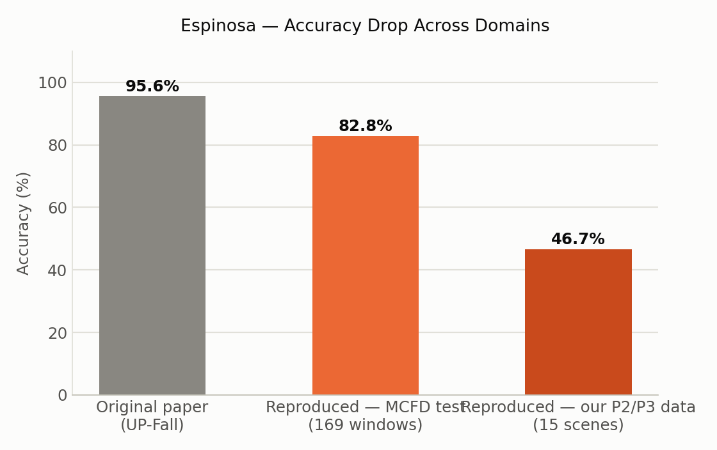
Figure 6.1 — Espinosa reconstruction: accuracy from the original paper's dataset, to a same-distribution MCFD test split, to the team's own recording conditions.
As Figure 6.1 shows, accuracy falls from 95.64% (original paper, UP-Fall dataset) to 82.84% (reconstruction, held-out MCFD split — same training distribution) to 46.7% (reconstruction, the team's own camera data) — direct evidence that whole-frame optical flow is highly sensitive to the specific camera angle, lighting, and distance present at training time, and motivating a training-free geometric design for Boundary Feature Fusion instead.

6.3. Results and Analysis

6.3.1. Results for P1
Beyond the closed-set Rank-1/mAP gap already shown in Table 6.2, the practical question is whether either architecture correctly resolves real gallery-matching cases. Figure 6.2 shows the cosine similarity scored by each system on the same four real test cases (two per camera), against the 0.6 matching threshold.
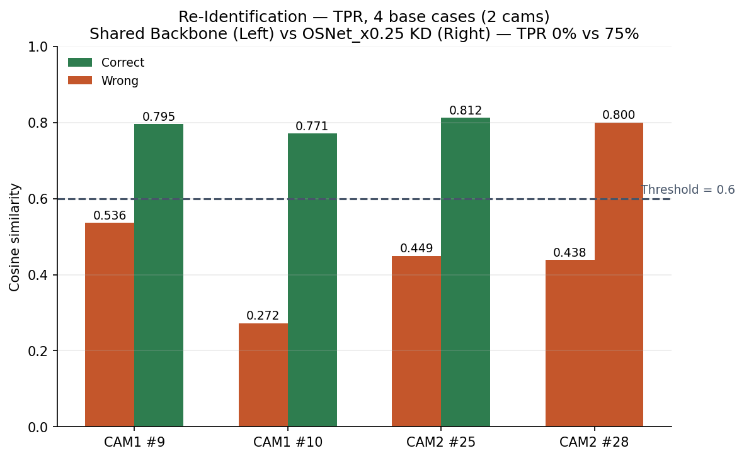
Figure 6.2 — Gallery-matching similarity per case: Shared Backbone vs. OSNet x0.25 (KD).
As Figure 6.2 shows, the shared backbone fails all four cases (0% TPR), scoring genuine pairs below threshold even when the underlying identity signal exists. OSNet x0.25 (KD) correctly resolves 3 of 4 (75%), extending to 19 of 25 cases (76.0%) once camera, lighting, noise, compression, and flip variants are included — versus 0 of 25 (0%) for the shared backbone under the same conditions. Knowledge Distillation from OSNet x1.0 narrows, but does not close, the Rank-1 gap to the pre-distillation OSNet x0.5 (52.00% vs 71.14%); notably, this gap shrinks sharply on the small, two-identity gallery that matches actual deployment conditions (76% vs 84% TPR), and is repaid with a lighter, faster, cooler model on the Jetson Nano 4GB (21.31 FPS vs 18.15 FPS; 1.73 GB vs 2.31 GB peak RAM).

6.3.2. Results for P2
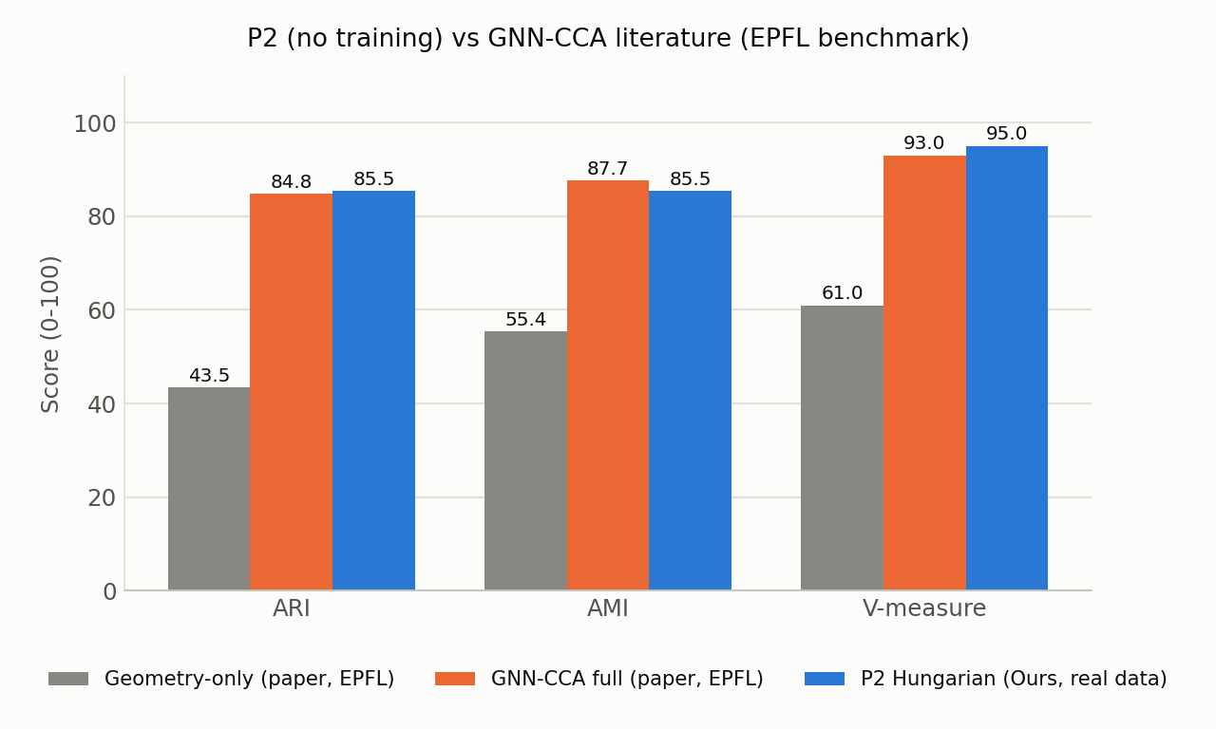
Figure 6.3 — Identity Association (Hungarian, own data) vs. Geometry-only and GNN-CCA full (literature, EPFL).
As Figure 6.3 shows, on the team's own two-camera, small-occupancy data (n = 840, four scenes × five augmented variants), training-free Hungarian matching reaches ARI and V-measure at or slightly above GNN-CCA's own literature-reported numbers on EPFL (ARI 85.45 vs 84.76; V-measure 95.01 vs 93.00), despite GNN-CCA clearly outperforming its own non-learned baseline at EPFL's larger scale (84.76 vs 43.49 ARI). This does not show geometry generally beats learned graph matching — the paper's own results show the opposite at their scale — but that the household deployment scale (1–2 people, 2 cameras) is small enough that most of the ambiguity a GNN is built to resolve does not arise, and that the choice of assignment algorithm matters as much as whether it is learned: in the hardest per-scene breakdown (two people standing close together), a naive distance threshold drops to 49.2% ARI while Hungarian's globally optimal assignment holds 100% across every tested variant.

6.3.3. Results for P3
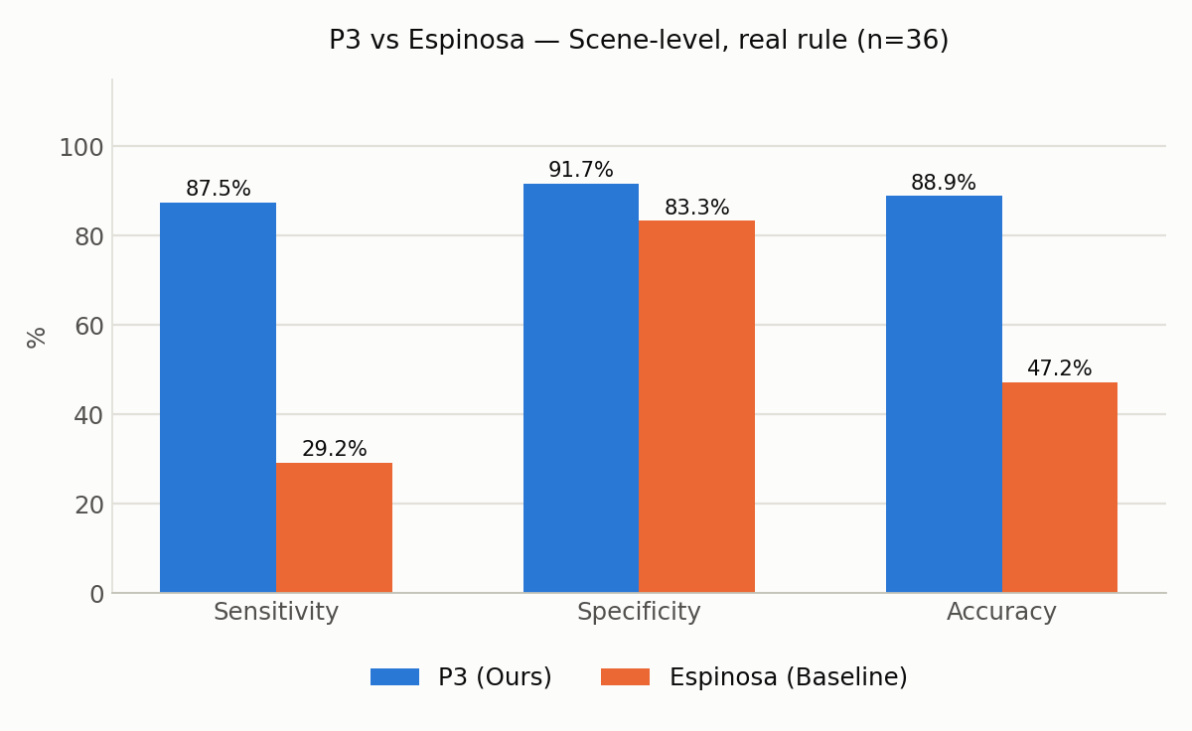
Figure 6.4 — Boundary Feature Fusion vs. Espinosa, scene-level, real fall_rule.py (n = 36).
Figure 6.4 reports scene-level results using the system's actual production decision rule (a transition to ‘lie’ within 2 s, or sustained lying for at least 1.5 s), on the same 36 scenes (24 Fall / 12 ADL) for both systems. Boundary Feature Fusion reaches 87.50% sensitivity and 91.67% specificity (88.89% accuracy), against Espinosa's 29.17% sensitivity and 83.3% specificity (47.2% accuracy) — an improvement on both axes at once, not a sensitivity/specificity trade-off. On the underlying fusion mechanism itself, average posture-classification confidence rises from 0.6069 (single weaker camera) to 0.6566 after fusion on real calibrated data (n = 165 matched frames), and the fused prediction changes the top-1 class in 29.09% of frames — evidence the mechanism has a measurable effect rather than adding noise. The remaining gap to perfect sensitivity (3 of 24 falls still missed) traces to frame-level posture classification (48.57% frame-level sensitivity): intermediate postures during the fall are sometimes misclassified for several consecutive frames, or a scene begins mid-fall with no valid ‘before’ state for the transition rule to key on.

6.3.4. End-to-End System Performance
Table 6.4 reports FPS, peak RAM, and peak temperature measured on the Jetson Nano 4GB for each pipeline stage under worst-case load. The detection/Re-ID stage (TensorRT/pycuda) and the fusion stage (TorchScript/PyTorch) could not be profiled together in a single process: running both simultaneously produced a CUDA-context conflict and, on retest, an out-of-memory kill (confirmed via dmesg) — confirming, rather than merely motivating, the decision to measure these stages separately.
Stage | FPS | Peak RAM | Peak Temp. | Target
YOLOv8n (320×320) + OSNet x0.25 KD, every frame | 21.31 | 1.73 GB | 36.25°C | ≥12 FPS, <3.5 GB, <80°C
Boundary Feature Fusion module only (TorchScript) | ~26.16 (25.12–27.96 across 5 runs) | 0.95 GB | 37.75°C | same as above
Identity Association (Hungarian, worst-case 10×10) | n/a — 9.6 ms / 100 iterations | negligible | negligible | n/a
Table 6.4 — Per-stage FPS, RAM, and temperature on the Jetson Nano 4GB (worst-case load).
As Table 6.4 shows, every measured stage clears its target independently; Identity Association's cost is negligible next to either learned stage. A previously reported Boundary Feature Fusion figure of 37.31 FPS could not be reproduced under the same checkpoints and was replaced with the re-measured, stable ~26.16 FPS reported here, following the principle that a number which cannot be reproduced is not reported as fact.

6.4. Ablation Studies
The one hyperparameter in Boundary Feature Fusion's otherwise training-free design is the Gaussian tolerance σ, which controls how strictly the fusion weight is concentrated around the approximate epipolar line. Figure 6.5 sweeps four candidate values, measured as a proxy on Identity Association data (used before real calibrated Boundary Feature Fusion data was available).
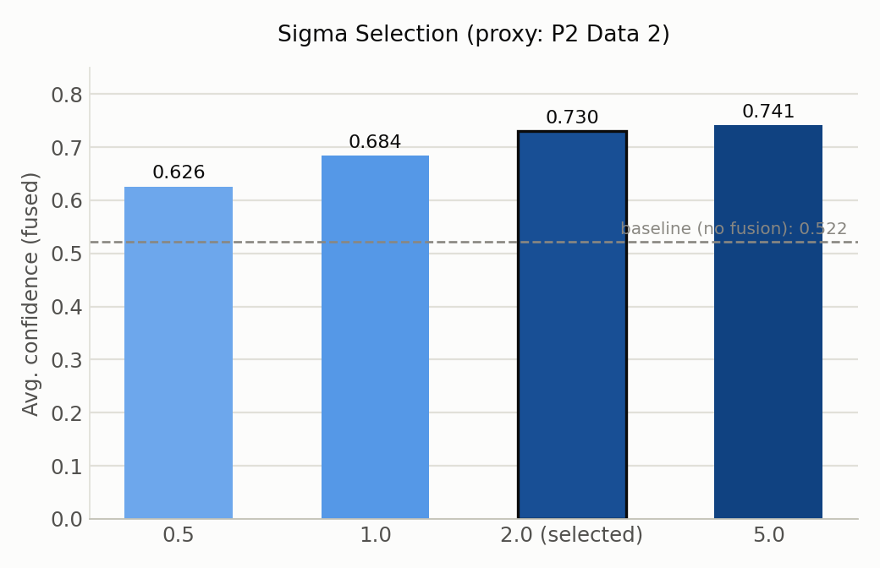
Figure 6.5 — Sigma selection: average fused-classification confidence vs. σ, proxy data.
As Figure 6.5 shows, confidence rises monotonically with σ (0.626 at σ=0.5 to 0.741 at σ=5.0, against a no-fusion baseline of 0.522), but gains taper sharply after σ=2.0 (+0.2081 vs baseline, versus +0.2188 at σ=5.0 — a further tenfold increase in σ for a 0.011 gain) while the rate of severe confidence drops continues falling (4.48% at σ=2.0 vs 2.99% at σ=5.0). σ=2.0 was selected as the point past which further loosening the geometric constraint mostly discards the locality that makes the fusion weight meaningful, rather than improving classification — later confirmed on real calibrated data, where the same fusion step raised average confidence from 0.6069 to 0.6566 (Section 6.3.3).

6.5. Discussion
Camera-conditional appearance drift is the most consistent source of error across the identity-related components. In Re-Identification, all remaining Tier-2 errors (6 of 25 cases, 24%) occur on CAM 2, where a person's second appearance is scored close to the wrong gallery identity — the same failure pattern observed for both OSNet variants, indicating a limitation tied to that camera's viewing angle or lighting at the relevant moment rather than to model capacity.
Missing detections, not matching logic, are the ceiling on Identity Association's remaining errors. Scene 3 (occlusion) scores identically under Hungarian and a naive threshold (74.3% both) because occlusion is a missing-detection problem upstream of any assignment algorithm — no matching method, learned or not, recovers an identity that was never detected.
Generalization fragility in learned, appearance- or motion-only baselines contrasts with the project's training-free geometric designs. Espinosa's reconstruction dropped from 95.64% (original paper) to 46.7% (the team's own conditions) purely from a change in camera setup, while Boundary Feature Fusion's fusion step, having no learned parameters, required no retraining for the team's own cameras.
The remaining sensitivity gap in Boundary Feature Fusion (87.50%, not 100%) is a frame-level classification limitation, not a rule-design flaw. Frame-level sensitivity (48.57%) is markedly lower than scene-level sensitivity (87.50%) because the scene-level windowed rule absorbs individual frame misclassifications during the visually ambiguous instant of falling; the residual 3 missed falls occur when this ambiguity persists across enough consecutive frames, or when a scene begins with no valid pre-fall state, to defeat both branches of the OR rule.

7. CONCLUSION AND FUTURE WORK
This thesis set out to validate three design decisions for multi-camera fall detection on constrained edge hardware, and Chapter 6 provides measured evidence, not assumption, for each. For Re-Identification, empirical testing rejected the original shared-backbone design outright (0% TPR across all 25 real test cases, across four training configurations) and confirmed an independent, distilled OSNet x0.25 model as the correct choice — reaching 76% TPR under the same conditions, at a lighter, faster, cooler footprint on the Jetson Nano 4GB than the larger OSNet x0.5 it replaced. For Identity Association, a training-free Hungarian-based matching step reached clustering scores comparable to a fully learned GNN baseline's own literature numbers, at negligible computational cost, at the household deployment scale this thesis targets. For Boundary Feature Fusion, the training-free, geometry-driven fusion mechanism reached 87.50% sensitivity and 91.67% specificity against a representative learned early-fusion baseline's 29.17% and 83.3% — an improvement on both axes at once, using a real production decision rule rather than a simplified proxy.
Future work includes: closing the remaining Re-Identification gap on CAM 2, where all residual errors currently concentrate, potentially via camera-conditional normalization or additional enrollment views; further reducing Boundary Feature Fusion's frame-level misclassification rate during the transitional instant of falling, since this is now the clearly identified ceiling on scene-level sensitivity; an ablation isolating multi-camera fusion's contribution under occlusion specifically, to directly support the multi-camera claim in the thesis title; and, if time permits, obtaining labeled data to run GNN-CCA directly on the team's own Identity Association data for a same-dataset comparison rather than the current cross-dataset one against literature-reported EPFL numbers.

